**Practical no.-**05

**Title:** Develop a program to implement linear and absolute layout

**Roll No.:**15 **Batch-** A **Date of Performance:** 08/01/2024



<?xml version="1.0" encoding="utf-8"?>

<androidx.constraintlayout.widget.ConstraintLayout xmlns:android="http://schemas.android.com/apk/res/android"

xmlns:app="http://schemas.android.com/apk/res-auto"

xmlns:tools="http://schemas.android.com/tools"

android:layout_width="match_parent"

android:layout_height="match_parent"

tools:context=".MainActivity">

<LinearLayout

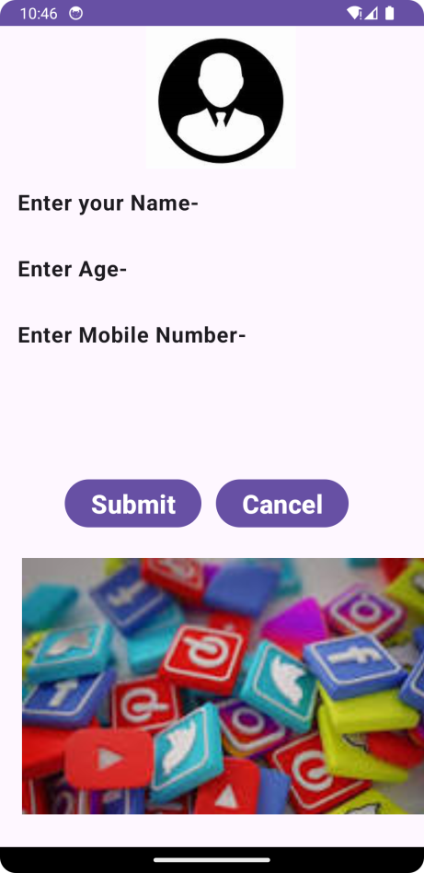 android:layout_width="409dp"

android:layout_height="729dp"

android:orientation="vertical"

tools:layout_editor_absoluteX="1dp"

tools:layout_editor_absoluteY="1dp"

tools:ignore="MissingConstraints">

<ImageView

android:id="@+id/imageView"

android:layout_width="match_parent"

android:layout_height="132dp"

app:srcCompat="@drawable/user" />

<com.google.android.material.textfield.TextInputLayout

android:layout_width="match_parent"

android:layout_height="match_parent">

<LinearLayout

android:layout_width="match_parent"

android:layout_height="match_parent"

android:orientation="vertical"

android:textAlignment="center">

<EditText

android:id="@+id/editTextText6"

android:layout_width="match_parent"

android:layout_height="wrap_content"

android:ems="10"

android:inputType="text"

android:text="Enter your Name-"

android:textAlignment="textStart"

android:textSize="20sp"

android:textStyle="bold" />

<EditText

android:id="@+id/editTextNumber"

android:layout_width="match_parent"

android:layout_height="wrap_content"

android:ems="10"

android:inputType="number"

android:text="Enter Age-"

android:textAlignment="textStart"

android:textSize="20sp"

android:textStyle="bold" />

<EditText

android:id="@+id/editTextNumber2"

android:layout_width="match_parent"

android:layout_height="wrap_content"

android:ems="10"

android:inputType="number"

android:text="Enter Mobile Number-"

android:textAlignment="textStart"

android:textSize="20sp"

android:textStyle="bold" />

<AbsoluteLayout

android:layout_width="match_parent"

android:layout_height="match_parent">

<Button

android:id="@+id/button5"

android:layout_width="wrap_content"

android:layout_height="wrap_content"

android:layout_weight="1"

android:layout_x="60dp"

android:layout_y="100dp"

android:text="Submit"

android:textAlignment="center"

android:textSize="24sp"

android:textStyle="bold" />

<Button

android:id="@+id/button6"

android:layout_width="wrap_content"

android:layout_height="wrap_content"

android:layout_weight="1"

android:layout_x="200dp"

android:layout_y="100dp"

android:text="Cancel"

android:textAlignment="center"

android:textSize="24sp"

android:textStyle="bold" />

<ImageView

android:id="@+id/imageView3"

android:layout_width="550dp"

android:layout_height="300dp"

android:layout_x="-62dp"

android:layout_y="177dp"

app:srcCompat="@drawable/social" />

</AbsoluteLayout>

</LinearLayout>

</com.google.android.material.textfield.TextInputLayout>

</LinearLayout>

</androidx.constraintlayout.widget.ConstraintLayout>